

**ETHIOPIAN ELECTRIC POWER**

**(EEP)**

**PROJECT PROFILE**

**for the**

**KOYSHA HEP**

**Generation Project**

**COUNTRY: Ethiopia**

**SECTOR: Energy**

**SUB-SECTOR: Power**

**Prepared by:**

Koysha HEP Office

Generation Construction

**July 2023**

Table of Contents

**1.** **Project Title** 3

**2.** **Project Summary** 3

**3.** **Koysha Project Location** 3

**4.** **Objectives and Justification** 4

**5.** **Project Components** 5

**6.** **Project Cost** 5

**7.** **Implementation Schedule** 6

**8.** **Project structure, organogram and Human Capital** 6

**9.** **Executing Agency** 7

**10.** **Financing Plan** 7

**11.** **Risks/Opportunity** 8

**12.** **Status of Variation Orders** 8

**13.** **Consolidated Progress** 9

**14.** **Estimated Analysis** 10

**PROJECT PROFILE**

# **Project Title**

**KOYSHA HYDRO-POWER PROJECT (Koysha HEP)**

# **Project Summary**

|  |  |  |
| --- | --- | --- |
| Sector | Energy | Remarks |
| Sub-Sector | Power |  |
| Project Type | Power generation / transmission |  |
| Estimated Project Duration | 143 months |  |
| Estimated Project Cost | Euro 2,42B |  |
| Estimated Consultancy Fee | USD 15.6M |  |
| Executing Agency | Ethiopian Electric Power (EEP) |  |
| Contracted Project Duration | 75 months |  |
| Contract Project Cost | EURO 2.52B |  |
| Mode of procurement | EPC |  |
| Contract Consultancy | Euro 15.6M |  |
| Project Contractor | Webuild (formerly Salini Impregilo) |  |
| Project Consultant | Stantec |  |
| Financing Agency | Italian export credit agency (Servizi Assicurativi del Commercio Estero) (SACE), who agreed to provide £1.15B ($1.68B) of financing for the Koysha HEP in April 2016.  The first tranche of the Euro 340M loan has been granted, but the IMF restricted further loans due to the country's current high debt burden. | |

# **Koysha Project Location**

The Koysha HEP hydroelectric project is located 129 km downstream of Gibe III Hydropower Project on the Omo River, between Gofa zone, Melekoza Woreda and Konta Zone in the South West Nation, Nationalities and People’s (SNNP) Regional State of Ethiopia. It is the fourth in a cascade of dams along the Omo River, after Gilgal Gibe (200 MW), Gibe II (420 MW), and Gibe III (1,870 MW) - all currently in operation.

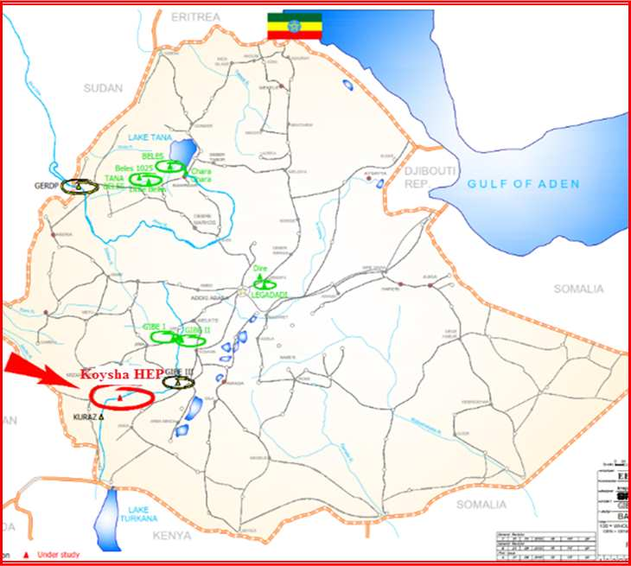

Figure 3.1: Location of the Project Area

# **Objectives and Justification**

The primary objective of the Koysha hydropower project is to generate electricity to relieve Ethiopia's acute energy shortage, and for export of any surplus electricity to neighbouring countries. The reservoir behind the Dam will serve to regulate flow of the Omo River and promote tourism.

Construction of the Koysha HEP is justified in that Ethiopia has a huge potential for hydropower generation currently largely untapped, and it is a natural resource which can be exploited in a very economic manner. Apart from helping to meet the country's ever growing energy needs, it will generate other significant economic benefits, including opportunities for more employment, improved agricultural productivity, increased industrial output, etc.

It is environmentally friendly; hydropower is green energy; greenhouse gas emissions will be enormously reduced, and water quality and supply improved.

# **Project Components**

* **River Diversion:** The layout for river diversion includes an upstream composite RCC cofferdam and two concrete culverts on the right bank of the river, designed to accommodate flows up to 3,000 m3/s during construction of the dam.
* **Dam**: The dam is an RCC gravity type, some 201.5m high with a crest length of 1012m; volume of RCC will be about 7.5 Mm3, and the reservoir created will be some 6,500 Mm3.
* **Spillway:** Floods will be discharged by means of a gated spillway, located on a saddle some 200m away from the Dam left flank. The spillway is designed to accommodate flows up to 13,100 m3/s; it comprises a long chute ending at a flip bucket discharging into a plunge pool adjacent to the river. The spillway includes six radial gates, each 14.5m wide x 17m high.
* **Middle level outlet:** The project includes two middle level outlets 6m in diameter, embedded in the Dam body, which will allow control of the reservoir level during early stages of impounding; also the release of ecological flows, and periodic lowering of the reservoir level for inspection and maintenance needs.
* **Intake:** a gated structure at the upstream face of the Dam
* **Penstocks:** The Dam will be crossed by two steel penstocks feeding an open-air Powerhouse to allow generation of electricity.
* **Powerhouse:** The Powerhouse is located on the left bank of the River and houses 6 Nr Francis turbines each capable of generating 300 MW, together with erection bays, a control building and step-up transformers located behind the Powerhouse.

Each unit is connected to three single-phase 400 kV transformers, making a total of 24 transformers, each linked through overhead lines to the 400 kV Switchyard.

* **Transmission Line:** These include400 kV double circuit lines - 146 km long - from Gibe III to Koysha Switchyard and from here to the national grid system.
* **Access road to the Project**: A permanent access road - 83km long - has been constructed from Ameya to the Koysha HEP project; it is a gravel road 7m wide, designed according to ERA designation DS6.

# **Project Cost**

The tables below summarize the project costs as follows

This table shows the original estimated project cost

|  |  |  |  |
| --- | --- | --- | --- |
| **Based on the original contract** | **Description** | **Total Contract amount (Euro)** | Remarks |
| Civil work | 1,929,415,335 |  |
| HW & HSS Work | 144,561,896 |  |
| EM work | 346,077,289 |  |
| **Total** | ***2,420,054,520*** |  |

# **Implementation Schedule**

Construction of the Koysha HEP commenced on 28 March 2016, with the original Contract schedule calling for project completion by June 2022 but it has been significantly delayed due to financial issues. The EPC Contractor has since proposed a revised schedule that would see impounding possible in January 2027, generation beginning mid-June 2027, and commissioning of all units by end-February 2028. This proposal is currently under negotiation, it has not yet been approved.

Currently, some 60% of the project work has been completed.

# **Project structure, organogram and Human Capital**

The project office to manage and administer the project implementation is organized under the Ethiopian Electric Power. The Project management is led by Project Manager and two Deputy Project Managers for the whole of the works with respective work units organized under them. One Deputy Project Manager responsible for Site Coordination is located at the Project Site. Offices for Project Engineering Support and contract administration managing technical and contractual issues, and Environmental and Resettlement work unit are organized under the Project Manager. There are over 40 engineers and technical staff and 20 semi-professionals to administer the contracts and assure quality of works jointly with the Employer’s Representative.

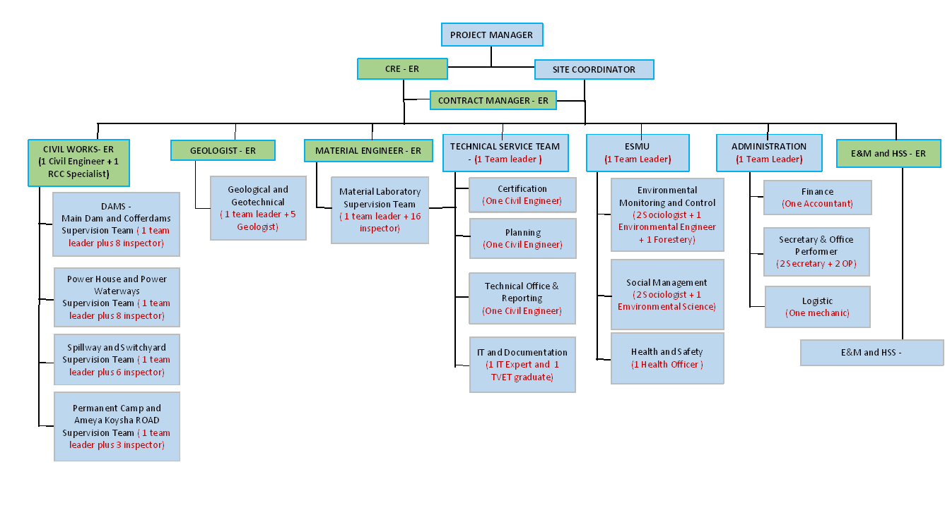

# **Executing Agency**

The Koysha Hydroelectric Project is owned by the Government of Ethiopia and is being implemented by Ethiopian Electric Power (EEP). The Project is being executed under an engineering, procurement, and construction (EPC) contract with Webuild (formerly Salini Impregilo).

The followings are the main executing agencies of the project:

* Ethiopian Electric Power: Owner
* Webuild S.p.A:Main EPC Contractor and the Sub Contractors under Webuild are CONS.AL.T (400kV Transmission Line from Gibe III to Koysha design, supply, construction, testing & commissioning), ATB Riva Calzoni S.p.A (design, supply of components, erection and commissioning of the Hydraulic Works and Hydro-mechanical Works.) and Andritz Hydro GmbH (Austria) (design, supply of components, erection and commissioning for the E&M Works).
* Stantec International Consulting Inc.: Main Consultant and the Sub Consultant under Stantec is Acute Engineering (Ethiopia).

# **Financing Plan**

* 1. **Financial Status**

|  |  |  |  |  |
| --- | --- | --- | --- | --- |
| **A.     Contractual Amount Details** | | | | |
| **Based on the original contract** | **Description** | **Total Contract amount (Euro)** | **Foreign Portion (Euro)** | **Local Portion (Birr)** |
| Civil work | 2,013,127,751.00 | 1,207,876,650.60 | 18,952,228,848.79 |
| HW & HSS Work | 150,834,068.00 | 120,667,254.40 | 710,000,091.53 |
| EM work | 361,092,701.00 | 306,928,795.85 | 1,274,790,838.83 |
| **Total** | ***2,525,054,520.00*** | ***1,635,472,700.85*** | ***20,937,019,779.15*** |
| **Amount after optimization (Less 105M Euro)** | | | ***1,530,472,700.85*** | ***20,937,019,779.15*** |
|  |  |  |  |  |
| **B. Current Financial Status** | | | |  |
| **Description** | **Type of payment** | **Euro** | **ETB** | **Remark** |
| Certified | Interim | 851,933,251.98 | 15,508,578,124.68 | The Interim payment certified of ETB portion includes a price adjustment and other related costs(which is not indicated in the total contract price. |
| Advance | - | 5,773,823,755.76 |
| Total amount certified | ***851,933,251.98*** | ***21,282,401,880.44*** |
| Paid | Interim | 767,769,488.94 | 15,508,578,124.68 |  |
| Advance | - | 5,773,823,755.76 |  |
| Total amount paid | ***767,769,488.94*** | ***21,282,401,880.44*** |  |
| Outstanding | Interim | 84,163,763.04 | 0 |  |
| Advance | - | - |  |
| Total amount outstanding | ***84,163,763.04*** | ***0.00*** |  |
|  |  |  |  |  |
| **C. Remaining Amount of the Project Cost** | | | |  |
| **Euro** | **ETB** | **Remark** | | |
| ***680,157,305.07*** | ***10,733,781,796.20*** | The remaining cost is calculated based on the contract price and the actual cost spent only on the work items. i.e. excludes the consequential costs | | |

# **Risks/Opportunity**

**Risks**

* Financial risk: The Koysha HEP is an extremely good investment, however the initial outlay is expensive; there is a risk that delays in financing will have a knock-on effect and make it eventually more costly.
* Material cost increment due to Russia Ukraine war: this will have a huge impact on material cost especially Electromechanical materials that are highly impacted by a huge energy and raw material cost increment in Europe.
* Socio-economic impacts: The Koysha HEP could have impact on the socio-economics of the region, loss of agricultural land, and the disruption of trade.
* Shortage of Cement Supply: The project suffers due to a frequent interruption of adequate cement supply and this will affect especially the placement of RCC on dam and this will in turn impact the project progress.

**Opportunity:** Both the river diversion layout and the energy-generation criteria of Koysha have been optimized to take advantage of the large flow regulation capacity of the Gibe III project upstream. Tandem operation of the two projects will allow for maximum energy generation and provide easy flexibility, thus guaranteeing power supply during both the dry season and periods of peak-demand.

# **Status of Variation Orders**

Only one variation order (VO-01) has been prepared and issued to date, concerning optimization of the generating units.

The original Contract included a Dam, water conveyance and 2,160 MW Powerhouse with 8 units; a gated Spillway, Switchyard, Transmission Line, various temporary and permanent camps, and an Access Road.

In February 2019, the Employer requested the Contractor to consider potential ways of optimizing the generating capacity of the Project and a corresponding reduction in the Contract Price. There followed much discussion and negotiation, but on 24 March 2021 the Parties agreed to change the generating configuration to 6 Nr units with a combined capacity of 1,800 MW, the omission of early generation facilities, and a reduction in the Contract Price of EUR 105M.

# **Consolidated Progress**

The following table summarises current progress made on design and construction activities.

|  |  |  |  |  |
| --- | --- | --- | --- | --- |
| **Work front** | **Overall progress** | **Remarks** | | |
| Overall design |  | 70% | Levels I and II |
| Main Dam - RCC placement | 2.72/7.7 Mm³ | 35.2% | Placement disrupted by a shortage of cement and heavy rainfall |
| Intake | 0 | 1% | Design |
| Penstock | 0 | 1% | “ |
| MLO | Manufacturing | 80% |  |
| Delivered | 40% | Steel plate |
| Installation | 0 |  |
| Powerhouse concreting | 86,105 / 168,000m³ | 51% | Also delayed by shortage of cement |
| E & M |  | 0% | Not yet commenced |
| Spillway excavation | 5.7/7.6Mm³ | 76% | Not critical |
| Spillway concreting | 28,412 / 358,400 m³ | 7.9% |  |
| Switchyard | Embankment | 31% | Suspended |
| 400KV Transmission Line | Gibe 3 HEP to Koysha HEP | 100% | Some repair work and rehabilitation in hand |
| Koysha to Grid | 0% |  |

# **Estimated Analysis**

As explained above, based on the original contract agreement, the completion of all civil works was planned to be completed by end of June 2022. However due to the shortage of the required foreign currency the basic milestones and the completion of the project is delayed and an additional cost is claimed by the EPC Contractor in relation to the extended period.

To bring the project on track, the revised estimated schedule for impounding, commissioning of all units, and start of power generation will be on January 2027, mid-June 2027 and end-February 2028 respectively.

Moreover, to ease the financial burden and shorten the time for completion , Ethiopian Electric Power (EEP) is carrying out am evaluation of the cost-effectiveness of the electro-mechanical (EM) works, as the initial sub-contractor Andritz' offer has recently increased significantly due to rising inflation in Europe. As a result, EEP is approaching the Chinese companies to determine whether there may be any time and cost-saving opportunities by offering the Electro-mechanical and Hydraulic Steel Structure works from the main contract.